**IMAT5264**

**P2586104**

**27th May 2020**

**East Midlands Candy Study**

(Total word Count: 2070)



**Lecturer: Bharti Patel**

# List of figures

Figure 2.1.1 exponential smoothing method to forecast sales for chocolate bar 5

Figure 2.1.2 linear trend model to forecast sales for adult mint sales 6

Figure 3.1.1 Relationship (cardinality) of selected tables 12

Figure 3.2.3 table of sales summary for product groups 14

Figure 3.3.1 setting range based on previous year performance 15

Figure 3.4.1 IDP content page 16

# Table Of Contents

List Of Figures 1

Table Of Contents 2

1. Introduction 3

2. Decision-Making Techniques 3

2.1 Forecasting 3

2.2 Linear Programming / Linear Optimisation 6

2.3 Simulation 8

3. The Business Intelligence (Bi) System 10

4. Compliance Issues 16

5. Conclusion And Recommendations 17

References And Bibliography 18

1. INTRODUCTION

The analysis in this report aims to address the business problems of East Midland Candy, a local confectionery manufacturer in Leicester, UK. Solutions to business problems are provided by implementing various business intelligence. The historical data about the company provides information that will be used in identifying the appropriate solutions to the problems. Notably, there are sales trends that require decision-making techniques in relation to predicting the forecasts for each product, evaluating production constraints, and proposing optimal production using a linear programming model such as sensitivity analysis. Also, A solution to the queuing problem of the business is recommended after using the simulation model and reviewing the staffing hours allocation to minimise staff hours.

Furthermore, the SAS BI system is used to visualise the data and view the overall performance of the business base on historical data.

1. DECISION-MAKING TECHNIQUES

## FORECASTING

Forecasting is an essential business application model used in all financial, marketing, operational planning, and human resources activities within an organisation to predict future event based on historical data. It is a requirement in the decision-making setting for inventory management, hiring and staffing, promotional campaigns, budgeting, and sales strategies—forecast account to variability in data measure at successive periods. Forecasting techniques in decision making evaluate the situations using time series data. The time-series data accounts for seasonal and irregular components detailing if there is variability at specific periods.

Although forecasting techniques provide the business with some understanding of future trends, the process may become unreliable as forecasts are based on certain assumptions from past data that may not repeat itself. Also, the forecasting techniques are a representation of future predictions and do not guarantee the event will occur. Also, analysing historical data requires lots of time and technology which smaller business may not be able to appreciate the benefits of forecasting.

* + 1. Smoothing Method

The Sales for the Chocolate bar show no underlaying trend; a quick view of the data shows sales are within a constant percentage, i.e., no trend. When the series of historical data does not display significant changes over time, the exponential smoothing method is applied for forecasting using smoothing constants a between 0.1 and 1 to determine the Forecast. The forecast error represented in Figure 2.1.1 is the difference between the actual sales and the forecast sales; the sum of the squared values is used to obtain the mean square error. The lowest mean squared error is used to select the best smoothing constant a that predicts a smoothed series of the forecast.

Figure 2.1.. exponential smoothing method to forecast sales for chocolate bar

* + 1. Linear Trend

The Sales of Adult Mint bar shows a systematic trend of a continuous increase in sales for in the historical data. The data grows by a constant amount over the period exhibiting a linear growth. Therefore, a linear trend model is adopted to predict sales forecasts. The intercept and slope of sales over the period are used to forecast an infinite number of months.

The equation of the linear model Yt = βₒ + β1t

Where **Yt** is the forecast, βₒ intercept of the linear trend, β1 is the sales growth constant, and **t** is the historical (arbitrary) time.

Figure 2.1.. linear trend model to forecast sales for adult mint sales

* + 1. Multiplicative Model

The Sales data for Children’s Treats follows the seasonal components of repeating trend patterns with the historical periods. From the representation in Figure 2.1.3, observe that there are no significant sales in Autumn and Winter, whereas, sales increase significantly in Spring and Summer. Predict sales from the historical data, the seasonal index of each quarter is calculated. The 4 MA is the four-quarter moving average for each quarter of the year. The centre moving average (CMA) eliminates seasonality defining the averages of each year. The CMA produces a combination of the seasonal trend and cyclic components- patterns or regularity in values above and below the trend line. The seasonal components are grouped by a quarter of each year, and seasonally adjusted values are obtained. The seasonal index measures the appropriate trend by multiplying the predicted values from the trend model.

The slope and intercept of the deseasonalised values are used to calculate the Forecast trend from the arbitrary time. The forecasted values are good for the model as they follow the historical trend.

* + 1. Model Evaluation

The linear model for the Adult mint suggests a continuous increase in sales for the next four quarters. The model is good at predicting sales. Still, the business would need to consider unexpected changes in the business ecosystem as the predicted values are only based on the historical data given.

## LINEAR PROGRAMMING / LINEAR OPTIMISATION

The linear programming methods aim to achieve the best models for the desired business outcome, e.g. maximise profit, minimise labour cost etc. The model requirements are represented by linear relationships techniques for optimising the objective functions. The linear programming technique helps in deciding the appropriate method of allocating resources within the organisation.

The model’s ability to provide the desired outcomes is limited by continuous variables as the model does not allow multiple optimisations. To achieve the best outcome, the relationship between the variables of the objectives and constraints must be linear.

* + 1. lp sensitivity analysis

The EMC problem shows that there are three constraints; supply of sugar is limited to 40,000kg, there are only 48litres of colouring, and the business commits to supplying 1,000kg of popcorn to the local cinema. The products standard and deluxe popcorn use 300g and 400g of sugar respectively and return a profit of 50p and 80p, respectively.

The objective of this sensitivity analysis is to maximise profit by identifying the amount of each product type to be produced given the decision variables.

Therefore, to make X1 Standard popcorn and X2 Deluxe popcorn total profit is the same as the objective function-maximise profit

The objective function is: Maximise 0.50X1 + 0.80X2

The sugar constraint is 0.3X1 + 0.4X2 <= 40000

The Colouring Constraint is 0.008X1 + 0.015X2 <= 48

The Supply to Cinema Constraint is X1 >= 1,000

Non-negative constraint is X1, X2 >=0

The table in figure 2.2.1 represents the calculation for the Maximised profit. The model suggests that

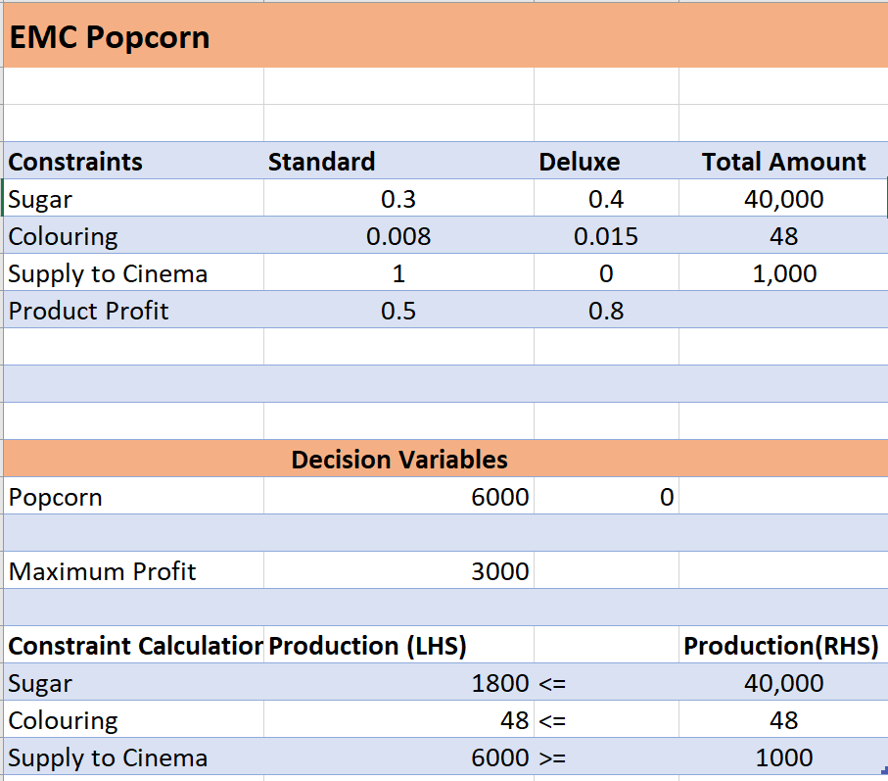

Figure 2.2.1 calculating sensitivity report for emc popcorn constraint

**Interpretation of the outputs in Figure 2.2.1.2**

* Information about the objective function:

The optimal values: X1 = 6000 and X2 = 0

The Range of Optimality X1 = no less than 0.42p but can be higher to any amount, X2 = can be reduced to an amount but can not be higher than 0.9375.

* Information about the decision variables:

Their reduced cost: X1 = 0 and X2 = -0.1375

* Information about the constraints (RHL):

The shadow prices: sugar = 0, Colouring = 62.0, Supply = 0

Ranges of feasibility = Sugar supply can be used to infinity and reduced 2,000. Colouring allowable increase is 1,0666.67 and decreases by 8. The supply cinema can increase to 6000 and decrease to any amount.

If shadow price, zero is a non-binding constraint.

Figure 2.2.1.2 sensitivity report for EMC constraint

* + 1. Staff Allocation

Figure 2.2.2 predicted hours shows the advised staff allocation hours

## SIMULATION

The simulation model is the simple process of emulating the process of the system by presenting the working of the system through other systems. Simulation models are useful as they help the company observe the changes and interactions that take place during the working hours. A queuing model is a huge part of simulation which comprises of serves or population and the queuing line.

2.3.1 Waiting lines model (queues)

From the results of the calculation in Figure 2.3.1, it is observed that as the number of servers **k** increase the number in the system there will be a significant reduction in the average time a customer has to wait on the line **W**.

It will be suggested to the EMC manager to increase the number of servers as this increase will improve the queuing system.

# 3. the BUSINESS INTELLIGENCE (BI) SYSTEM

The BI system is a high-level data management ecosystem, widely supported by Information Technology to provide tactical support at any stage in the decision-making process. The process of developing a BI system accounts for complex architecture which involves data modelling, reporting, visualisations, data query, OLAP, data warehousing, and analytical methods (Bara, A. et al. 2009). The core of these processes is used in developing an effective BI system with visualisations for East Midlands Candy.

3.1 information map STUDIO

The metadata from the data warehouse is translated into information tables in the information map studio. Other SAS BI applications rely on the information from the information maps studio to obtain a streamlined user view of the data for reporting and analysis. In this analysis, it is assumed that the required data items are Sales Amount, Units, Customer Name, Region, Customer Type, Product Group, Subcategory, Product and Year.

The required tables are selected from the resources pane to the design pane in the selected resources tab. The relationships pane builds a relationship between the tables in the selected resources pane Figure 3.1 is a representation of the relationships based on their cardinality which joins tables with one or many rows in one table to one or many rows in another table. The many table is called the fact table, while the one table(s) is called the lookup table, the join method is a star schema. In this analysis, the Candy Summary is the many, and the other tables join using a unique identifier.

Figure 3.1.. Relationship (cardinality) of selected tables

The Information Map Contents Pane enables changes in the properties of each column (data item) in the table to either category -containing character data or measure -numeric data for computations. The required filters for analysing the data are created based on the business user’s needs. For a more concise representation, each data item is saved in a folder. An essential feature of the information map is the test information map pane which allows the analyst to view the selected data briefly before building reports and dashboards. In this analysis, the BI application is created for the Sales Department of East Midlands Candy.

Figure 3.1.2 overview of information map studio interface

3.2 web reports

The principle of the web report is the ability to create reporting applications designed to easy access of viewing, creating, and sharing articles on the web across business users. In this analysis, the data source of the web report is the information maps studio which contains data that has been appropriately modelled. The Web report interface allows the BI analyst to create page breaks by a chosen parameter which are organised to highlight specific relevancies to the business user. The report wizard has two modes, the Edit mode used for assigning data and the view mode for viewing the results of the assigned data. The edit and view modes contain the report body where tables and graphs can be found (Figure 3.2.1).

Figure 3.2.1 web report edit mode

The reports built for the East Midlands candy projects the sales total for each product group in tabular format by applying filters to the assigned data in the edit mode. For ease of understanding, each product group is aggregated separately, i.e. sales total for candy and sales total for nuts. Another requirement of the business user is a view of sales to all customers; a separate report is created using the bar-line chart to view the unit and deals to each customer per year. This simple model enables the user to identify an area of improvements or decline in sales and provides support in the decision-making process.

Figure 3.2.2 bar-line chart in view mode

Figure 3...3 table of sales summary for product groups

3.3 dasHboards

The BI Dashboards provides real-time information about how well the business is performing by monitoring key performance indicators (KPI), metrics and specific data. The dashboard can link with the reports to update interactive and meaningful visualisations. In this analysis, the user specifies interests for sales in the current year 2003; the dashboard is customised for each sales department and show the totals sales to each customer in a product group. The data source and filter are stored, and cleaned data in the information maps studio. A range gauge provides instant information on the performance of the company in the current year in comparison to the previous year.

Figure 3...1 setting range based on previous year performance

In the SAS BI Dashboard, each visualisation is created by selecting an indicator, a bar chart with bullets and pie chart are the chosen indicators for this analysis.

Figure 3.3.2 SAS bi dashboard representation

3.4 Information delivery portal

The Information delivery portal is a page containing organised portlets for viewing reports and dashboards on one content page. The portal allows the business users to connect directly to the applications on the SAS platform. The Information delivery portal created in this analysis is represented in Figure 3.4.1 and show the different content pages for each Sales Department.

Figure 3...1 IDP content page

3.5 system evaluAtion and limitations

Overall, The SAS BI System conveys the data accurately and helps the business user identify new business opportunities and problems. The applications tackle sales performance for each department by using the data source, filters, data visualisations, reporting and dashboard features. The web development environment makes it easy for all business users to connect to the BI system from any location. However, most of the non-technical users would require some training to understand better the functionality of the system (Dell’aquila et al., 2008).

Notably, the SAS BI system provides tremendous insights into the data. However, the following limitations of the software would require improvements:

* The difficulty in making changes to the data item name, filename, document directory, etc., as every little change affects other connected SAS platforms.
* The Information delivery portal is challenging to customise when trying to fit the reports and dashboard to the screen
* Compared to other BI software such as Excel and Microsoft Power BI the user interface is the SAS software looks a little outdated.
* Lack of slicer for filtering in the reports and dashboard resulted in the need to create multiple reports and dashboards.
* The drill-through feature could be improved upon as the IDP page does not accommodate multiple sections of the same report.

# 4. compliance issues

4.1 Software Licensing

Software licensing involves adhering to a legally binding document issued by the system provider to the end-users. The document’s goal is to govern the software’s use and redistribution, thus protecting the provider from copyright issues etc. Critically, the software license contains provisions which allocate liability and responsibility between the parties entering into the license agreement. Notably, most BI systems are proprietary software which implies that the source codes are hidden (i.e. closed source) by a provider(s). It signifies that limitations and restriction imposition are introduced regarding granting rights to the software.

4.2 Data Protection

Data protection involves the process of safeguarding important information from different risks such as corruption, compromise, or loss of data. The idea of data protection is prominent within compliance because the exponential growth of data indicates that more data will be created and stored. For instance, the Data Protection Act contains a set of principles adhered by different organisations for the lawful processing of personal data. Notably, compliance to data protection will encourage the accuracy, security and lawfully of individual personal data. The UK adheres to GDPR, where it states that data subjects have a right not to be subject to automated decision-making or profiling (Raab, 2020). If the data is not stored properly, there could be mishandling of data which can disrupt the accuracy of the company’s data

4.3 Training

A sound BI system provides a complete solution to enunciate necessities of the organisation but requires specialised abilities. The apparent requirement for broad training has resulted in most small businesses distancing from BI systems due to issues with balancing the cost of training. As with the case of EMC, most of the manager and decision-makers are low-level IT Users; therefore, progressive training will be required to utilise the BI framework.

4.4 Real-time reports and performance

Availability of reports and constant update to necessary personnel may difficult due to the distribution of files in various sections of the firm. Therefore, it is encouraged that a business analyst is employed on-site to oversee data storage and warehousing.

# 5. CONCLUSION AND RECOMMENDATIONS

This analysis gives an in-depth view of applications of BI systems and how they can improve the business processes of East Midland Candy.

The forecasting techniques implemented towards the predicating the sales of the Adult Mint Bar, Chocolate Bar and Children’s treats perfectly models the historical data and predicts possible sales for the next quarter or year.

The Linear programming model (sensitivity analysis) used to maximise profit in the constraint issue show that all the resource show be used in the production of Standard Popcorn. Also, the sensitivity analysis defines the allowed increase or decrease in the value of the constraints. The model also explains who the business can minimise staff hours using the staffing allocation calculation.

A waiting lines systems calculations provide insights on how to resolve the customer waiting for lines by evaluating the reduction in waiting time W for each increase in the number of servers/ staff.

The SAS BI system provides an information map studio for building relationships between the data tables which is the data source for other SAS BI Platforms such as Web Report Studio, SAS BI Dashboard and The Information Delivery Portal. The entire BI system shows reports of the Totals for each Sales Department and filters through the product groups -candy and nuts and the customer data. The Information delivery portal serves as an overall viewing page of the reports, dashboards and other plugins.

EMC’s overall performance can be improved if other business parameters can be implemented as marketing and improved staffing. Also, the new Business Understanding department will require the need for advanced-level IT users to explain the better process the company data and create real-time reports and dashboard to monitor the sales of 2003 which currently shows that it is below target from the previous year.

# REFERENCES AND BIBLIOGRAPHY

Bara, A., Botha, I., Diaconita, V., Lungu, I., Velicanu, A. and Velicanu, M., 2009. A model for business intelligence systems' development. *Informatica Economica*, *13*(4), p.99.

Raab, C., 2020. Information privacy, impact assessment, and the place of ethics. *Computer Law & Security Review*, p.105404.

Dell’aquila, C., Di Tria, F., Lefons, E. And Tangorra, F., 2008. *Evaluating Business Intelligence Platforms: A Case Study.*